FinSeek
Technical Design Document
V1.0
Author :Amol Meshram;Sayan Banerjee;Gayathri Devi Ramraj
Date:11 June 2025
Team: AI Sentinetals

Document Change Record
Date | Version | Author | Change Details
11 June 2025 | V 1.0 | Amol Meshram  Sayan Banerjee  Gayathri Devi Ramraj | First draft complete and submitted for review
Document Signoff
Nature of Signoff | Person | Signature | Date | Role
Approvers | DTCC
Approvers | Finos
TABLE OF CONTENTS
Document Change Record 2
Document Signoff 2
1. Preface 4
2. Introduction 4
3. As-IS 4
4. Solution Architecture 5
5. Solution overview 5
6. Technology stack 6
7. Data usage 6
8. Performance testing 6
9. Challenges faced 7
10. Scalability 7
11. Industry collaboration 7
12. Application Screenshot 8
13. Conclusion 8

Preface
This document is a generic Technical Design Document document for use by FinSeek Projects. It provides guidance and template material which is intended to assist the relevant management or technical staff, whether client or supplier, in producing a project-specific Technical Design Document. It is also useful background reading for anyone involved in developing or monitoring

Introduction
Financial data firms typically store their information in structured databases. To derive insights, analysts must first understand the schema and then craft and execute multiple queries to retrieve the necessary data, a process that often involves substantial manual effort.
Develop a finance-focused chatbot powered by a Large Language Model (LLM)—preferably using the open-source DeepSeek model. However, due to access limitations, Anthropic Claude 3.5 Sonnet was used as an alternative. The LLM is integrated with a Retrieval-Augmented Generation (RAG) pipeline via LangChain, enabling it to query both internal financial datasets and external financial sources. Due to time constraints, zero-shot learning approaches were not explored. The system is designed to respond accurately to user queries related to finance and is implemented as an open-source solution.

As-IS

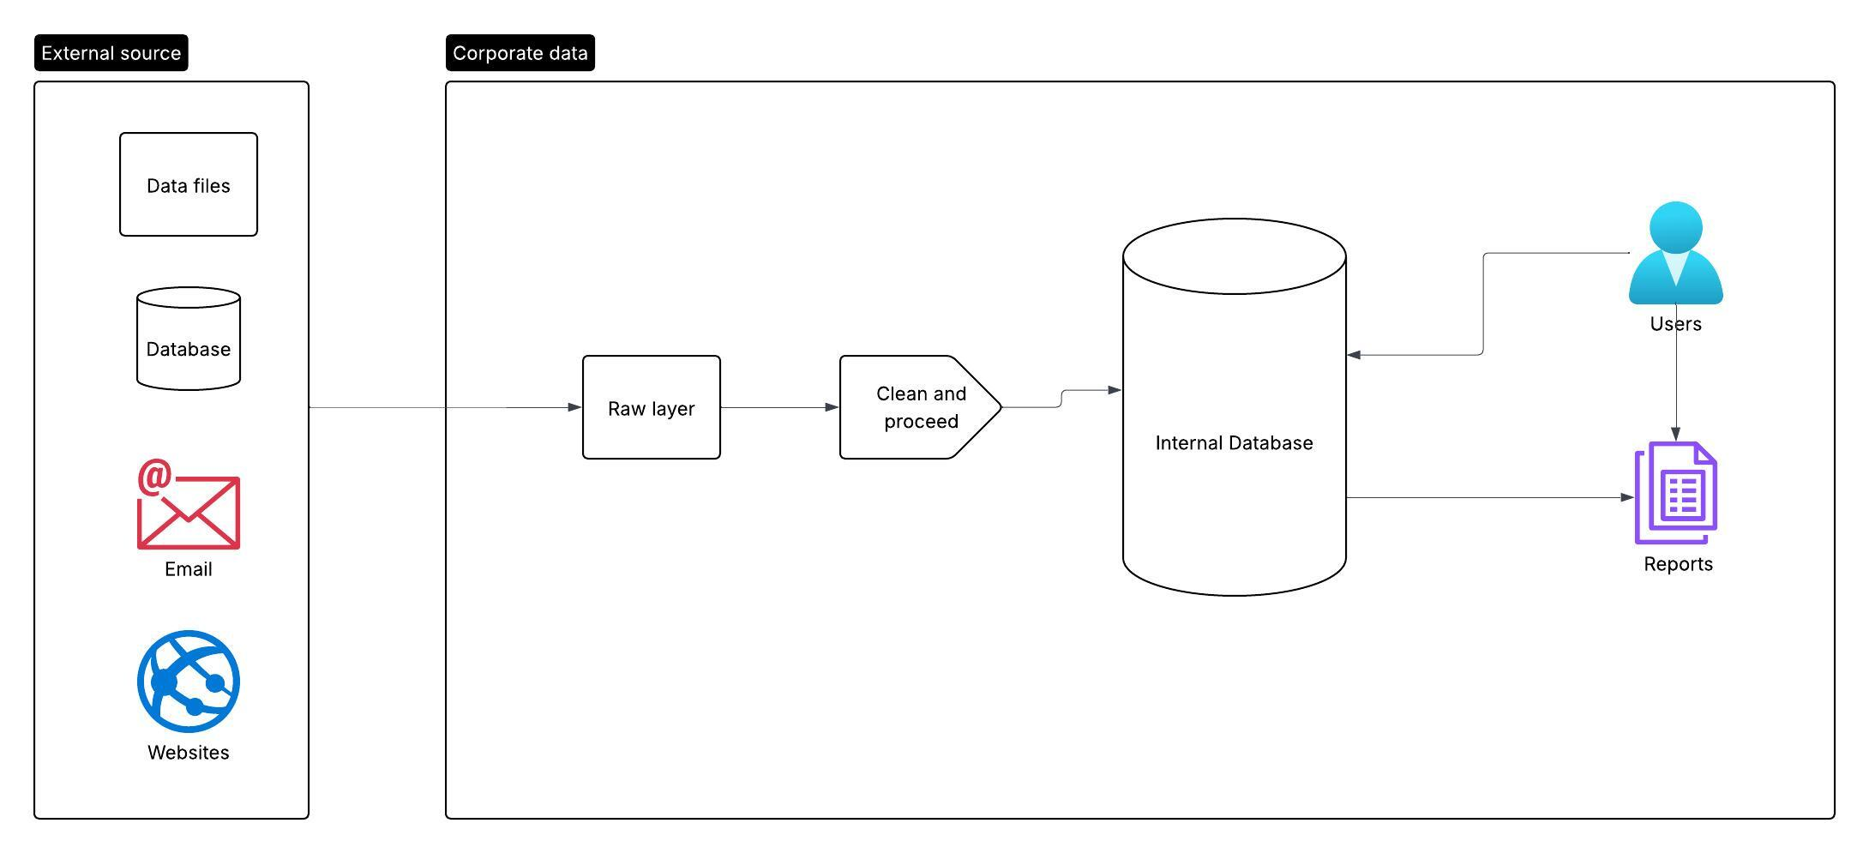

Solution Architecture
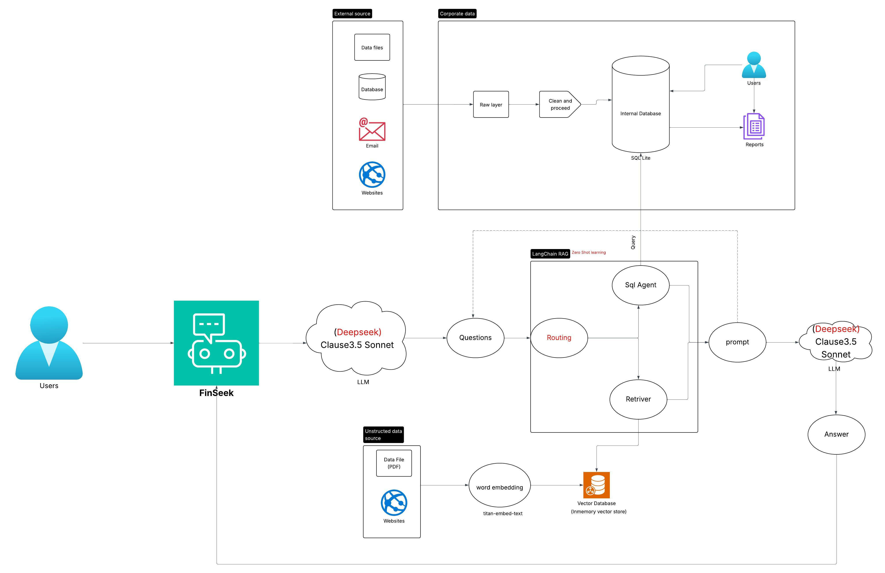

Solution overview

User Interaction

The user initiates a query through a Chatbot UI (Streamlit -web interface) to get the required information from the internal system

This is sent to LLM

LLM

LLM used is Claude3.5 Sonnet via Amazon Bedrock (Deekseek had issue with bedrock_converse API , so Anthropic Claude 3.5 Sonnet is used).

Advanced Retrieval-Augmented Generation (RAG)

LangChain was used for RAG, agent based. (This can be enhanced/tested with zero-shot learning)

LangChain accesses a SQLite database hosted on Amazon EC2 populated with structured data . SQL queries are auto-generated based on prompt context

LangChain queries a InmemoryVectorstore for semantically indexed content from webpages and PDF documents. (Documents are pre-processed, chunked, and embedded using Amazon’s Titan embedding model and saved in InmemoryVectorstore)

Output Delivery

The response is returned to the Chatbot UI, completing the interaction.

Technology stack
Function | Service used | Services to try
LLM Inference | Amazon Bedrock: Anthropic Anthropic Claude 3.5 Sonnet | Deepseek R1
Vector DB | Inmemory Vectore store
File Storage | Amazon S3
Embedding Generation | Bedrock Titan Embeddings
RAG | LangChain | Zeroshot learning
Structured Query (SQL) | SQLite on EC2
Static UI Hosting | streamlit
Programming Language | Python
Deployment | Git actions/Terraform
Hosting platform | EC2 (T3 large)

Data usage for LLM

RAG will operate exclusively on unrestricted data. The following categories are excluded from RAG processing:

PI

PII

Restricted data

Confidential data

Performance testing

Performance testing couldn’t be done since it was difficult to considerable volume of data for structured and unstructured finance data.

Challenges faced

The Bedrock Deepseek R1 model only functioned via the Invoke API and generated errors when called through the Converse API. This was needed for a chat interface,so switched to Anthropic Claude 3.5 Sonnet. Also GPU EC2 instance was not provided to install and run the DeepSeek Model.

Since it was difficult to considerable volume of data for structured and unstructured finance data, performance testing couldn’t be done

Due to time constraint couldn’t implement routing in RAG

Scalability

The proposed architecture leverages the existing structured database, ensuring no disruption to the current application. We’re augmenting it with unstructured data, LLMs, RAG, and a chatbot for enabling low-latency retrieval of the required information.

Entire code is deployed as pipeline, so it is easy to set up multiple instane .

Industry collaboration

This architecture can be seamlessly integrated with a “Finance Data Provider” and easily extended to support the “stock market” industry as well.

Application Screenshot

Conclusion

During the hackathon, we built DeepSeek—a self-service investigative chatbot that lets users query corporate actions in structured data using natural language. The solution combines Streamlit, Anthropic Claude 3.5 Sonnet via AWS Bedrock, a LangChain agent-based Retrieval-Augmented Generation (RAG) framework, an in-memory vector database, and SQLite. DeepSeek intelligently interprets user prompts, retrieves relevant information from PDFs, websites, and databases, and delivers clear, context-aware financial insights in real time

